3rd Grade Engineering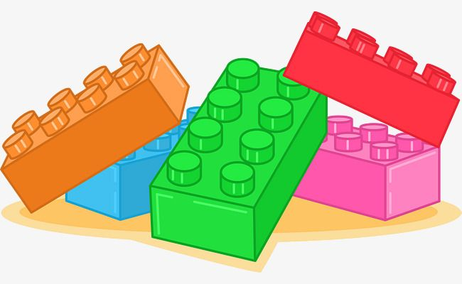 Year At A Glance

August 2025 |  | September 2025
*Students will learn the Rules/Expectation of Engineering. |  | *Students will develop an understanding of the core concepts of technology.
*Students will develop an understanding of the characteristics and scope of technology. |  | *Students will be able to build a brick model of a tool that will aid them in accomplishing a task.
*Students will be able to build and experiment with wheels and axles. |  | *Students will be able to write design requirements and plan steps for a brick model design.
*Students will build a brick model of the Gate of Horus and will consider the economic and cultural influences that caused the gate to be built.
October 2025 |  | November 2025
*Students will develop an understanding of the relationships among technologies and connections between technology and other fields of study. |  | *Students will develop an understanding of the effect technology has on their lives and society.
*Students will be able to make brick models of a parachute and a lander that integrates more than one technology. |  | *Students will be able to build a brick model of an elevator based on their knowledge of pulleys.
*Students will be able to identify and create a brick model of a cross-section of the layers of the Earth. Students will be using technology to enhance the study of science. |  | *Students will be able to build a brick model of a dam and will experiment with the consequences of building the dam if it should fail.
December 2025 |  | January 2026
*Students will develop an understanding of the effects technology has on the environment. |  | *Students will develop an understanding of the role of technology in society.
*Students will be able to build and understand the role of a composter in protecting the environment. |  | *Students will be able to build a brick model of a butter churn. Students will also be able to understand how society’s needs and wants shape the products manufactured.
*Students will build an aerial cable car as a model of an energy efficient technology. |  | *Students will understand the concept of marketing and its importance in the success of technology.
February 2026 |  | March 2026
*Students will develop an understanding of the influence of technology on history. |  | *Students will develop an understanding of the attributes of design.
*Students will be able to identify and model an adze using bricks. Students should be able to develop a theory as to how the adze was developed. |  | *Students will be able to create a design for a wrecking ball to be used in demolition. Students should be able to identify and explain the features of their design.
*Students will be able to identify and model a boat using bricks. Students should be able to develop a timeline to show how boat technology has evolved over time. |  | *Students will be able to create a design for an emergency shelter. Students should be able to identify the requirements of an emergency and how to meet them.
April 2026 |  | May 2026
*Students will develop an understanding of the Engineering Design Process. |  | *Students will use different problem-solving approaches to solve problems.
*Students will be able to participate in a brainstorm session and develop different purposes for a brick model of unknown use. |  | *Students will build a brick model an arch and then innovate to make a new arch that is stronger but uses the same number of bricks to build it.
*Students will be able to design and create a brick model of the Sears Tower. Students should be able to define a model and explain how a model is different from the original object that is being studied. |  | *Students will build a brick model of a pendulum, form a hypothesis using the scientific method, and then chart the resulting data in a data table.

Please note: Lessons may be changed, added, or deleted.

